JESUIT SPIRITUALITY
Reflections
CENTER

St. Charles College PO Box C
313 Martin Luther King Dr. Grand Coteau, LA 70541-1003

Tel: 337-662-5251

Spring 2021
Website: jesuitspiritualitycenter.org Email: office@jesuitspiritualitycenter.org

RETREATS WILL RESUME IN JUNE

3, 5, AND 8-DAY RETREATS
8-day retreats begin on first date.
3 & 5-day retreats begin on either date.
Mon., Jun. 7 or Thu., Jun 10 Mon., Jun., 21 or Thu., Jun. 24 Mon., July 5 or Thu., July 8 Mon., July 19 or Thu., July 22 Mon., Aug. 2 or Thu., Aug. 5 Mon., Aug. 23 or Thu., Aug. 26 Tue., Sep. 7 or Fri., Sep. 10 Mon., Sep. 20 or Thu., Sep. 23 Mon., Oct. 4 or Thu., Oct. 7 Mon., Oct. 18 or Thu., Oct. 21 Mon., Nov. 1 or Thu., Nov. 4 Mon., Nov. 15—3 & 5 days only Mon., Dec. 6 or Thu., Dec. 9
Thirty-Day Retreat
Tues., Sep. 7 to Sun., Oct. 10
Suggested Retreat Fees
3-Day Retreat $270.00 5-Day Retreat $450.00 8-Day Retreat $650.00
30-Day Retreat $2,400.00 Deposit: $75.00
On-going Spiritual Direction
$40.00 per visit

The Jesuit Spirituality Center will resume retreats and in-person spiritual direction in June. The dates for these retreats are listed to the left. Group retreats and other programs are cancelled for the remainder of this year. We hope to resume them in 2022.
We want to open cautiously, with the well-being of our guests and our resident Jesuits in mind; so we will restrict the number of retreatants on any day to 18 only. This will enable retreatants to distance in the dining room. We will have daily Mass in the large chapel above the dining room, so that retreatants may distance there also. This will allow our housekeepers to have time also to clean and disinfect more carefully.
Please note the following:
All retreatants are required to have been completely vaccinated at least two weeks before arriving for a retreat. Please bring your vaccination card with you.
Masks and distancing will be required at Mass and during meetings with directors unless the director decides otherwise and with the agreement of the retreatant. Retreatants should wear a mask when they are outside their bedrooms.
Changing circumstances may lead us to cancel retreats, and to loosen or tighten our restrictions as seems appropriate.
A registration form is provided on the back of this page. You may use it, or you may register at our website: jesuitspiritualitycenter.org.
2020 Retreats
The Spring newsletter usually includes a report on the statistics for the previous calendar year. The Center was shut down from March 11 throughout the rest of the year. Before that, the JSC hosted only 75 people for retreats, 22 for weekend-workshops, and 79 for other programs, for a total of 176.

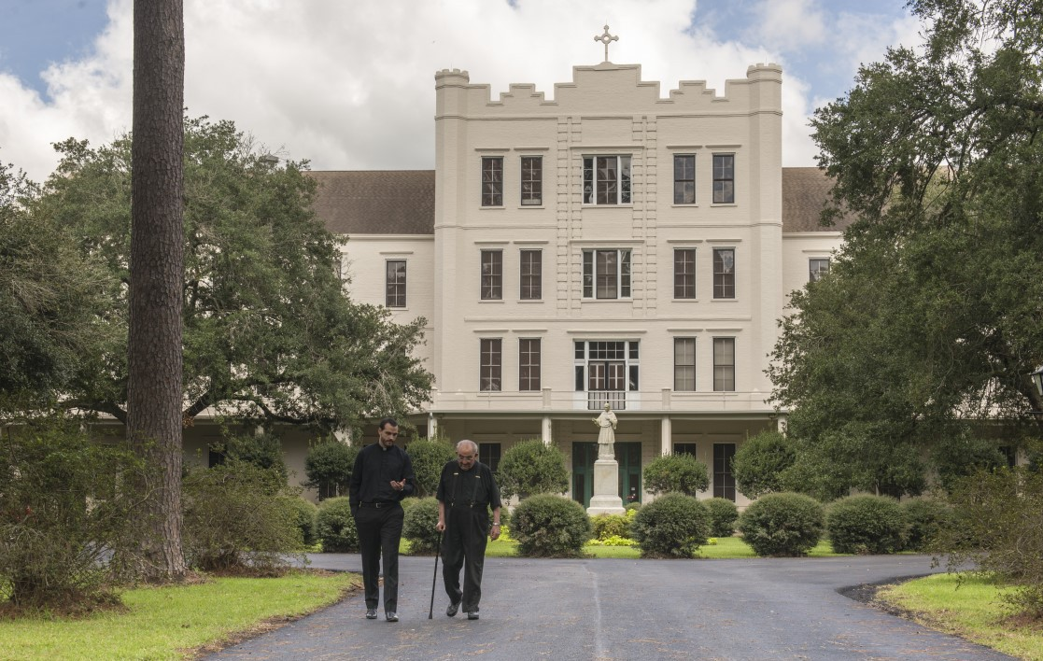
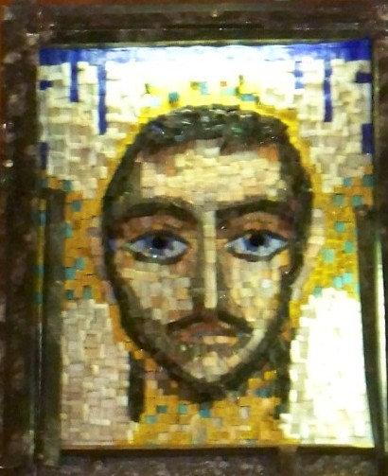
St. Charles College, the Spirituality Center, the Jesuits,
the Staff, and
the beautiful grounds all await the return of our guests!

Jesuit Spirituality Center

From the Director—
The Jesuit Spirituality Center began giving retreats in 1972. That means that in 2022 we will celebrate our
50th ANNIVERSARY!
The Center was envisioned as a place where priests, brothers, and nuns could make silent individually-directed retreats of 6, 8, or 30 days. A few lay men and women were also accepted. Over time, with the decline in the number of religious vocations, the mission of the Center has developed. Lay men and women now comprise 75% of all retreatants. Interestingly, a newly-ordained Father John Payne was among the first Jesuits to serve on the staff of directors; and he is once again on the staff.
Reflections

The Jesuits here have truly been blessed in that only two of us, as far as we know, contracted covid. One of those had no symptoms and recovered fully. The other was already experiencing advanced health problems, and died very shortly after testing positive. We have carefully observed directives from health- care authorities.
Mrs. Turner, Mr. Hebert, Fathers Payne, Tran, and I have all maintained good health, and are looking forward to resuming the ministry of the Center.
I am most grateful to our generous benefactors who have continued to help us. Each day I pray especially for our co-workers, our benefactors, those people we minister to, and our families and loved- ones.
May God keep you and yours safe and healthy!
Tony Ostini, S. J.

The ministry of the Spiritual Exercises which the Jesuit Spirituality Center offers is made possible thanks to the generous contributions, both large and small, of its supporters and benefactors. The Jesuits of the Central and Southern Province of the United States also contribute substantially to its ministry. The Jesuit Spirituality Center is a non-profit and tax exempt ministry. It is one of only a few retreat centers in the United States that offer individually-directed retreats of three, five, eight, and thirty days. The Staff of the Center remember gratefully in prayer all the benefactors and supporters of the Center.

REGISTRATION FORM OR REGISTER AT jesuitspiritualitycenter.org
If photocopied, please do not alter the size of this form. Submit this form for registration and confirmation.
Retreat Dates Desired
Title Name
First Last (Religious Initials)
Mailing Address
Street City State ZIP
Daytime Phone Birth Date Occupation Church Denomination E-Mail Address Have you made a directed retreat before at the Spirituality Center? Have you made one elsewhere? A name and phone # to contact in case of an emergency:
YES, I WILL HAVE BEEN FULLY VACCINATED 2 FULL WEEKS BEFORE THE START OF MY RETREAT.
initial
Special Needs?
Deposit Enclosed: $ Make out checks to: Jesuit Spirituality Center, and write the dates of your retreat on the check, please.
Charge my credit / debit card: Amount $ ­­ (circle one:) Visa MasterCard Discover (circle one:) credit or debit
_ _ _ _ _ _ _ _ _ _ _ _ _ _ _ _ _ _ _ _ _ - _ _
Account Number Security Code Expiration Date
Signature Date:

PLEASE COMPLETE AND RETURN THIS FORM AT LEAST ONE WEEK PRIOR TO THE ARRIVAL DATE TO:

